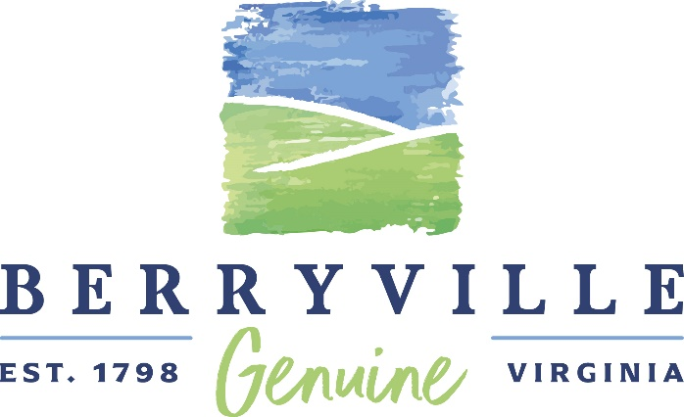
AGENDA
Town of Berryville

ARCHITECTURAL REVIEW BOARD
Wednesday, April 7, 2021 - 12:30 p.m.
Berryville – Clarke County Government Center
101 Chalmers Court - Meeting Room AB – Second Floor

AGENDA

- Call to Order – Susan Godfrey, Chair

- Approval of Agenda

- Approval of Minutes – March 3, 2021

- Sign Review
Shadi Madain, Owner, Greenway Auto, is requesting a Certificate of Appropriateness for a wall sign at the property located at 39 West Main Street, identified as Tax Map Parcel number 14A5-((A))-1 zoned C General Commercial.

- Sign Review
33 West Main, LLC, (Charles Twigg and Katherine Lange, members), is requesting Certificates of Appropriateness for a freestanding sign, wall sign, and projecting signs for Berryville Optometry located at 33 West Main Street, identified as Tax Map Parcel number 14A5-((A))-4, zoned C General Commercial.

- Other
- Adjourn

Berryville – Clarke County
Government Center
101 Chalmers Court, Suite A
Berryville, VA 22611

[T] 540/955-1099
[F] 540/955-4524
[E] info@berryvilleva.gov
www.berryvilleva.gov

Harry Lee Arnold, Jr. Erecka L. Gibson
Mayor Recorder

Council Members
Donna Marie McDonald Diane Harrison Grant Mazzarino Kara C. Rodriguez
Ward 1 Ward 2 Ward 3 Ward 4

Keith R. Dalton
Town Manager

