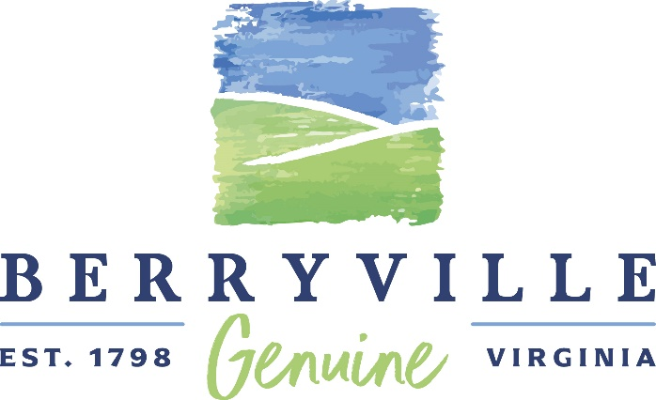
Creative Communities Partnership Grant
Participant Application
Deadline: February 20, 2026
Please note: applicants must be an organization whose primary purpose is the arts (production, presentation or support of dance, literary arts, media arts, music, theater, or visual or related arts), that are incorporated in Virginia. They must also have their headquarters and home seasons, or activities equivalent to a home season, within the state. Funding cannot be provided for payment to performers for specific performances. For more information about the Virginia Commission for the Arts’ Creative Communities Partnership Grant program, please visit https://vca.virginia.gov/grant/creative-communities-partnership-grants/ . Additional information can also be found on the Town of Berryville’s web site at http://berryvilleva.gov/.

Name of Arts Organization:________________________________________________________
Applicant Name:_________________________________________________________________
Last First M.I.
Address: __________________________________________________________________
Street Address Apartment/Unit#
__________________________________________________________________
City State ZIP Code
E-Mail: __________________________________________________________________

Phone: __________________________________________________________________
Has this organization received a Local Arts Grant from the Town of Berryville in the past?
m Yes m No
Grant amount requested: (maximum $4,500) ________________________________

Please provide a brief description of the organization:

Berryville – Clarke County
Government Center
101 Chalmers Court, Suite A
Berryville, VA 22611

[T] 540/955-1099
[F] 540/955-4524
[E] info@berryvilleva.gov
www.berryvilleva.gov

Harry Lee Arnold, Jr. Erecka L. Gibson
Mayor Vice Mayor

Council Members
William Steinmetz Paul Perez Grant Mazzarino Ryan Tibbens
Ward 1 Ward 2 Ward 3 Ward 4

Keith R. Dalton
Town Manager

Please give a brief description of the organization, proposed project, and who will participate.

Please list the organization’s officers, board of directors, and key staff as applicable.

How will the community benefit from the project?

Please attach the organization’s budget.

Please select the category that best describes your organization’s primary focus.
m Arts Education
m Dance
m Multidisciplinary
m Music
m Opera
m Theater/Storytelling
m Visual Arts
m Other (please describe) __________________________________________

Populations Benefitted
Please select any categories that, by your best estimate, will make up 25% or more of the population that will directly benefit from the award during the period of support.
Racial or Ethnic Groups
m American Indian/Alaskan m Asian/Pacific Islander m Black/African American
m Hispanic/Latino m White/Caucasian m Other
Other Distinct Groups
m Individuals with disabilities m Individuals in institutions m Individuals below the
(hospitals, hospices, assisted poverty line
care, etc.)
m Individuals with limited English m Military veterans/active m Youth at risk
proficiency duty personnel
Age
m Children/Youth (0-18 years) m Adults (25-64)
m Young adults (19-24 years) m Older adults (65+ years)
Arts Education Choose the one item which best describes the funded activities.
m 50% or more of the funded activities are arts education directed to K through 12 students, higher
education students, pre-kindergarten children, and/or adult learners (including teachers and artists)
m Less than 50% of the funded activities are arts education directed to K through 12 students, higher
education students, pre-kindergarten children, and/or adult learners (including teachers and artists)
m None of the funded activities involve arts education

_____________________________________________________________ _____________________
Signature Date

